The Real Mount Sinai

By

Simcha Jacobovici
Adjunct Professor, Religious Studies Department, Huntington University

Summary:
This paper examines a number of candidates for Mount Sinai in light of the Biblical coordinates, and the Biblical and Rabbinic criteria. Har Karkom does not pass the test. Jebel Hashem el Tarif does.

Introduction:
The Rabbinic approach to the Torah is to start with the “pshat” i.e., the simple surface level, before moving to deeper levels of meaning. The methodology of this paper follows the pshat of Mount Sinai. It asks a simple question: is there a mountain in the Sinai desert that conforms to all – not some – of the Biblical criteria? I believe there is. But if there’s not, I don’t believe it’s possible to locate the holy mountain. After all, Mount Sinai is described in the Bible and nowhere else. Since there were hundreds, if not thousands, of holy mountains then any one of them can be anointed as Mount Sinai. If one is ready, for example, to move Mount Sinai out of the Sinai, why stop there? Why not move it out of the Middle East?

Some believe this is an issue of Biblical “literalism” versus a more archaeological approach, but it’s not. I’m simply arguing that before you creatively look for the mountain in all sorts of places, you owe it to the Bible to investigate if there’s a mountain that literally conforms to its criteria. If there is, your quest has ended. If there isn’t, for my part, I’m out of the “find Mount Sinai” game, because there are simply no criteria by which to judge.

To return to the question at hand; is there a mountain that conforms to all the Biblical criteria?
Candidates:
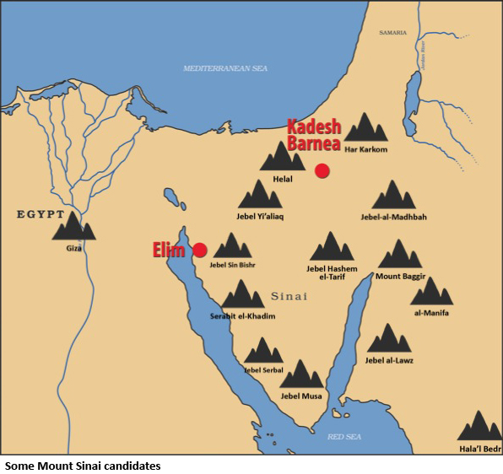
There have been many candidates for the holy mountain of God/Horeb/Mount Sinai. These include:
- Jebel Musa, the “traditional” site in Sinai, favored by Christians since the time of Queen Helena in the 4th century CE/AD.
- Jebel Sinn Bishr, favored by Professors Menashe Har-El and David Faiman.
- Helal, a mountain in northern Sinai.
- Jebel Serbal, a mountain in southern Sinai.
- Giza, in Egypt.
- Har Karkom, in Israel, favored by Professor Emmanuel Anati.
- Jebel al-Lawz, in Saudi Arabia, a favorite with Evangelical Christians and Hershel Shanks.
- Al-Manifa, in Saudi Arabia.
- Hala’l Bedr, in Saudi Arabia.
- Mount Baggir, in Jordan.
- Serabit el-Khadim, in central Sinai.
- Jebel-al-Madhbah, the high place in Petra, Jordan.
- Jebel Yi’aliaq, east of the Mitla Pass, Sinai.
- Jebel Hashem el-Tarif, excavated by Professor Uzi Avner and proposed by me as Mount Sinai.
As stated above, the problem with the various Mount Sinai theories is that – for the most part – they ignore these Biblical criteria. If we ignore those criteria, any mountain can be the mountain of God. According to the prophets, idolatry was practiced on all the “high places” (e.g., 2 Kings 12:3). So it would not be surprising to find cult artifacts on mountain tops. Put simply, there were many “holy mountains”, holy to various people. Just because a mountain was a cultic site does not make it Mount Sinai. To be Mount Sinai, a mountain has to conform to the criteria given in the Torah. For example, it has to be in the Sinai – hence the name. This immediately rules out all the mountains in Saudi Arabia. We’re down to 11.

Mount Sinai has to be 11 days from Kadesh Barnea (Deuteronomy 1:2). Scholars generally agree that Kadesh Barnea is Ein El-Qudeirat. The United Nations High Commissioner for Refugees (UNHCR) estimates that a mass of refugees can move no more than 15 km per day. If this is the case, Mount Sinai can be no more than 165 km from Kadesh Barnea/Ein El-Qudeirat. This rules out Jebel Musa, Jebel Sinn Bishr, Giza, Baggir, Serabit, Madhbah, Serbal and Yi’aliaq, all of which are out of range. We’re now down to 3 mountains: Har Karkom, Helal and Hashem el-Tarif.

To reiterate: if we accept the modern identification of Kadesh Barnea and we use modern criteria for refugee migrations, there are only three candidates - out of the many proposed - that are 11 days from Kadesh Barnea.

But there are other criteria. For example, the mountain has to be 14 days from the Biblical Elim. The Biblical itinerary states that the revelation at Mount Sinai happened 50 days after the start of the Exodus. This tradition is still celebrated by Jews around the world with the counting of the Omer. Every day, beginning on the first day after Passover eve, we count with a blessing, until we reach 50, at which point Shavuot/Pentecost is celebrated. According to the Biblical itinerary, the tribes of Israel reached Mount Sinai 5 days prior to the giving of the Torah on the 1st of Sivan (Exodus 19:1. See also Shabbath 86b; Mekhilta; Targum Yonathan; Rashi; cf. Ibn Ezra). The Torah was given on the 6th of Sivan (See Aryeh Kaplan, The Living Torah, commentary on 19:11).

The Torah also tells us that the children of Israel reached the Wilderness of Sin or Tsin/Zin on the 15th of the month of Iyar i.e., 30 days after they left Egypt (Exodus 16:1). The Torah makes clear that the Wilderness begins just beyond Elim. In other words, it took the Israelites from the 15th of Iyar to the 1st of Sivan to get from the area of Elim to Mount Sinai i.e., c. 14 days. The Biblical Elim has been identified by Professor Menashe Har-El with the modern oasis of Ayun Musa. Scholars agree that even if he’s wrong about the precise location, he is right about the general location. This gives us a second Biblical coordinate. Again, if we use UNHCR criteria for the mass movement of refugees, Mount Sinai has to be 210 km from the area of Ayun Musa. This rules out Har Karkom. Put simply, if we accept the timetable of Exodus 16:1 and 19:1 we cannot reconcile it with Professor Anati’s suggestion.

Even if we allow for very quick, Olympic caliber Israelites, the third geographical criterion provided by the Torah is that Mount Sinai has to be within “goat/sheep grazing distance” from a Midianite camp. After all, Moses’ encounter with the burning bush happens when he is grazing Yithro’s flock (Exodus 3:1-22), and the episode occurs on Mount Sinai - “All of you will then become God's servants on this mountain” (Exodus 3:12, emphasis added). The Torah is quite clear: “Moses tended the sheep of his father-in-law Jethro, sheik of Midian. He led the flock to the edge of the desert, and he came to God's Mountain, in the Horeb area” (Exodus 3:1).

According to the Talmud, Yithro was an outcast from Midian (Exodus Rabba l.c). The Midianites were nowhere near the three remaining locations for Mount Sinai. They were located in modern Saudi Arabia. A survey of the Sinai found no Midianite presence there.
There was one exception, however, modern day Timna. Interestingly, there are depictions of flock grazing on rock art in Timna. This is our only candidate for the area of Yithro’s camp, and it is, as the Torah states, close to the “edge of the desert”. There is no other candidate for the Midianite camp of Yithro. When I consulted with Bedouins in the Timna area about the distance they travel from their camps in order to graze their flocks, they told me that they travel 15-25 km maximum, unless there is a drought in which case they could wander as far as 60 km. Even if we take the bigger number, the Timna coordinate puts both Mount Helal and Har Karkom out of the picture.
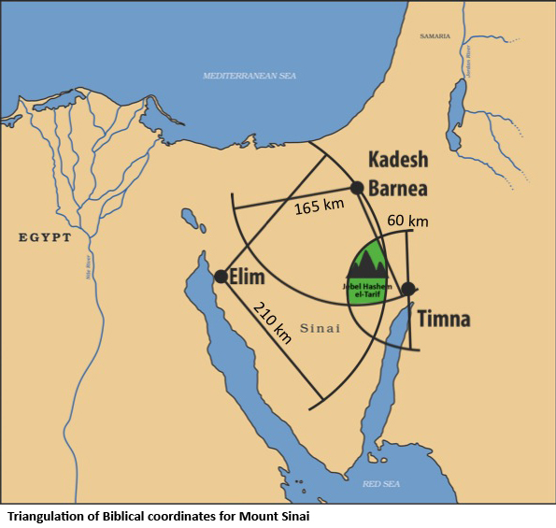
To summarize, if we use the three geographical coordinates provided by the Torah, namely; Kadesh Barnea, Elim and the only Midianite site in the Sinai desert, we are left with only one possible candidate for the Biblical Mount Sinai – Hashem el-Tarif.

We can now ask the question: does Hashem el-Tarif conform to the other traditions surrounding Mount Sinai?

- According to Rabbinic sources, Mount Sinai is the lowest of the mountains in its region. Hashem el-Tarif is the lowest mountain in its region.
- According to the Torah, Mount Sinai was able to accommodate hundreds of thousands, if not millions of Israelites (Exodus 12:37). In other words, the mountain needs a huge plateau around it, so as to accommodate a very large number of people. Hashem el-Tarif has a huge plateau around it.
- According to the Torah, Moses was asked to create a barrier – “set a boundary” -between the mountain and the people (Exodus 19:12). Hashem el-Tarif is surrounded by a stone demarcation that is visible to this day.
- According to the Torah, Moses destroyed the golden calf, ground it “and threw the dust into a stream that flowed down the mountain” (Exodus 32:20 and Deuteronomy 9:21. Emphasis added). Hashem el-Tarif has evidence of travertine on top of the mountain. You can readily pick up huge pieces of travertine to this day. Travertine is created by fresh flowing water.
- According to the Torah, Moses carved the stone tablets of the Ten Commandments (Exodus 34:4). It’s clear that Moses wasn’t working with hammer and chisel. Travertine is a soft stone. It also conforms to the Talmudic tradition that it was transparent. When you put travertine up to the light it is transparent and you can see engravings on both sides. This conforms to the Rabbinic tradition.
- According to the Torah, Moses spoke to the people from on top of the mountain (Exodus 19:7). Hashem el-Tarif has a natural stage and close by a natural amphitheater creating perfect acoustics and the ability to speak to the people below from the mountain above.
- According to the Torah, there is a prominent cleft in which Moses hid, protected from the glory of God (Exodus 33:22). The natural stage at the end of the mountain is separated from the mountain itself by a very prominent natural cleft.
- According to the Torah, the mountain was considered holy prior to the Exodus (Exodus 3:1). Hashem el-Tarif has the highest concentration of open-air sanctuaries in the Sinai.
- According to the Torah, Mount Sinai is close to Mt. Seir (Deuteronomy 1:2 and 33:2). To this day, the extension of Hashem el-Tarif is called “Seira”.
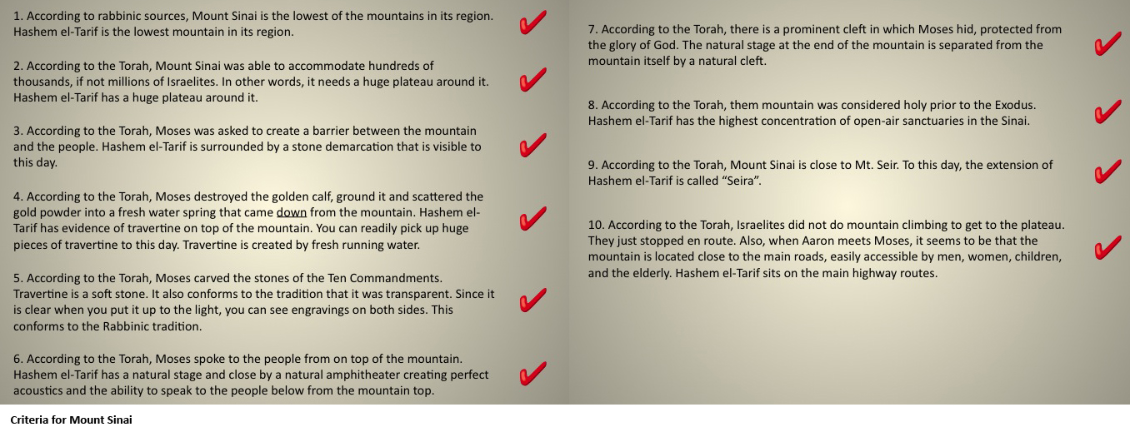
- According to the Torah, Israelites did not engage in professional mountain climbing to get to the plateau surrounding the mountain. They just stopped en route. Also, when Aaron meets Moses, it seems to be that the mountain is located close to the main roads, easily accessible by men, women, children, and the elderly (Exodus 4:27). Hashem el-Tarif sits on the main Sinai highway routes.

Put simply, Hashem el-Tarif conforms to every one of the Biblical criteria. In contrast, Har Karkom does not qualify with most of the criteria. It is not low, it is not easily accessible, it is not surrounded by a huge plateau. There are no acoustics. Those on top of the mountain cannot easily communicate with those below it. There is no natural spring on top. It’s not near Seir. It’s not near a road. And it’s too far from any Midianite presence whatsoever. The only things that can be said for it is that it’s close enough to Kadesh Barnea and it was a holy mountain. Perhaps Israelites scratched Torah related symbols e.g., the “Ten Commandments” on rocks at Har Karkom. But that doesn’t make the mountain Mount Sinai. You simply can’t move the Israelites from their Biblical location or the Midianites from their homes. Nor can you turn the Israelites into professional mountain climbers to accommodate the Anati hypothesis. Har Karkom is a very, very interesting mountain but there is no need to speak of it as Mount Sinai when Hashem el-Tarif fits the criteria.

Mount Sinai has been found!

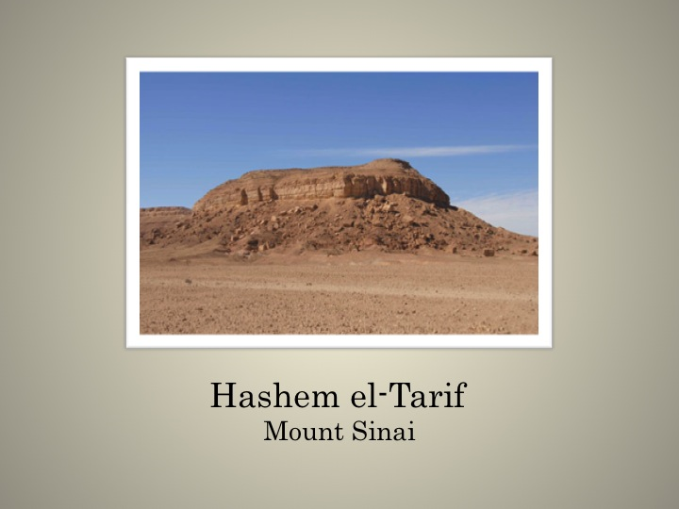

M. Har-El, Sinai Journeys: The Route of the Exodus, (Ridgefield Pub. Co., San Diego, 1983).
? B. Rothenberg, Timna: Valley of the Biblical Copper Mines, (Thames and Hudson Ltd, 1972). Three small sherds of Midianite ware were found in Bir el-‘Abd in the northern Sinai right on the route that the Bible explicitly states that the Israelites did not take. See Rothenberg, B. and Glass, J. 1983. The Midianite Pottery. In: Sawyer, J.F.A. and Clines, D.J.A., eds. Midian Moab and Edom. The History and Archaeology of Late Bronze and Iron Age Jordan and North-West Arabia (Journal for the Study of the Old Testament Supplement Series 24) Sheffield, p. 83. “The largest corpus of this ware has come largely from…Timna,” see Tebes, Juan Manuel. Pottery Makers and Premodern Exchange in the Fringes of Egypt: An Approximation to the Distribution of Iron Age Midianite Pottery in Buried History, 2007, Volume 43, p. 11.
Midrash Tehillim on Tehillim 68:17; see also Likkutei Torah, Parshas Bamidbar 16b ff.
Bereshith Rabbah, chap. 31.

